**Chapter 8 Practice AP Questions** Name: ________________________  
1) =

(A)  (B)  (C) 

(D)  (E) 

2) is found by using which of the limits below?

(A)  (B)  (C) 

(D)  (E) 

3) In decomposing by the method of partial fractions, one of the fractions obtained is

(A)  (B)  (C)  (D)  (E) 

4) Which of the following improper integrals converges?

I. 

II. 

III. 

(A) I only (B) III only (C) I and II (D) II and III (E) I and III

5) is

(A)  (B)  (C) 4 (D) -4 (E) nonexistent

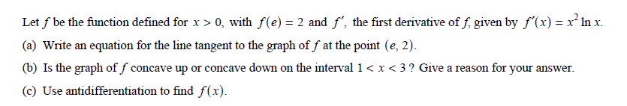

6)

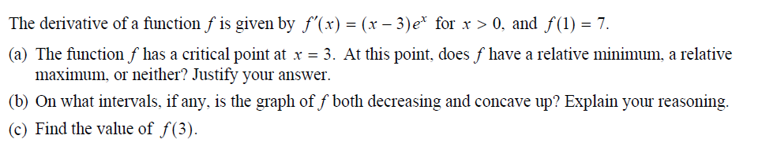

7)